1. Create a new React Application with the name “myfirstreact”, Run the application to print “welcome to the first session of React” as heading of that page.

App.js

import React from 'react';

import './App.css';

function App() {

return (

<div className="App">

<h1>welcome to the first session of React</h1>

</div>

);

}

export default App;

App.css

.App {

text-align: center;

}

.App-logo {

height: 40vmin;

pointer-events: none;

}

@media (prefers-reduced-motion: no-preference) {

.App-logo {

animation: App-logo-spin infinite 20s linear;

}

}

.App-header {

background-color: #282c34;

min-height: 100vh;

display: flex;

flex-direction: column;

align-items: center;

justify-content: center;

font-size: calc(10px + 2vmin);

color: white;

}

.App-link {

color: #61dafb;

}

@keyframes App-logo-spin {

from {

transform: rotate(0deg);

}

to {

transform: rotate(360deg);

}

}

Output

1. Create a react app for Student Management Portal named StudentApp and create a component named Home which will display the Message “Welcome to the Home page of Student Management Portal”. Create another component named About and display the Message “Welcome to the About page of the Student Management Portal”. Create a third component named Contact and display the Message “Welcome to the Contact page of the Student Management Portal”. Call all the three components.

Components – Home.js

import React from "react";

const Home = () => {

return (

<h1>Welcome to the Home page of Student Management Portal</h1>

)

}

export default Home;

Components – Contact.js

import React from "react";

const Contact = () => {

return (

<h1>Welcome to the Contact page of the Student Management Portal</h1>

)

}

export default Contact;

Components – About.js

import React from "react";

const About = () => {

return (

<h1>Welcome to the About page of the Student Management Portal</h1>

)

}

export default About;

App.js

import React from 'react';

import './App.css';

import Home from './Components/Home';

import About from './Components/About';

import Contact from './Components/Contact';

function App() {

return (

<div className="App">

<Home />

<About />

<Contact />

</div>

);

}

export default App;

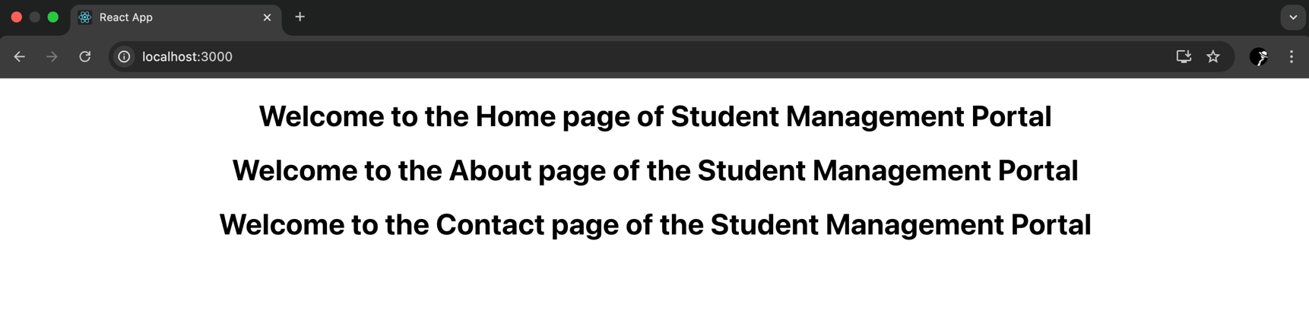OUTPUT

1. Create a react app for Student Management Portal named scorecalculatorapp and create a function component named “CalculateScore” which will accept Name, School, Total and goal in order to calculate the average score of a student and display the same.

Components – CalculatorScore.js

import React from 'react';

function CalculateScore(props) {

return (

<div>

<h1>

{props.name} scored {props.score} in {props.subject}

</h1>

<h2>

Percentage: {(props.score / props.total) \* 100}%

</h2>

<p>

Result: {((props.score / props.total) \* 100 >= 40) ? "Pass" : "Fail"}

</p>

</div>

);

}

export default CalculateScore;

Stylesheets – mystyle.css

div {

border: 5px outset red;

background-color: lightblue;

text-align: center;

}

h1 {

color: blue;

font-family: 'Courier New', Courier, monospace;

font-size: 300%;

}

h2 {

color: darkcyan;

}

p {

color: green;

font-size: 160%;

}

App.js

import React from 'react';

import './Stylesheets/mystyle.css';

import CalculateScore from './Components/CalculateScore';

function App() {

return (

<div>

<CalculateScore name="Shashank" subject="ReactJS" score={90} total={100} />

<CalculateScore name="Ritik" subject="ReactJS" score={30} total={100} />

<CalculateScore name="Aakash" subject="ReactJS" score={80} total={100} />

</div>

);

}

export default App;

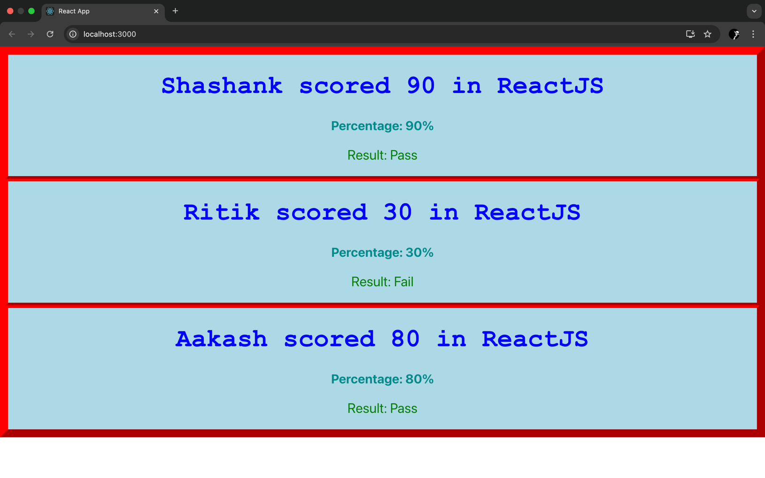OUTPUT

1. BLOGAPP

Post.js

class Post {

constructor(id, title, body) {

this.id = id;

this.title = title;

this.body = body;

}

}

export default Post;

Posts.js

import React, { Component } from 'react';

class Posts extends Component {

constructor(props) {

super(props);

this.state = {

posts: []

};

}

loadPosts() {

fetch('https://jsonplaceholder.typicode.com/posts')

.then(response => response.json())

.then(json => this.setState({ posts: json }))

.catch(error => console.error('Error fetching data:', error));

}

componentDidMount() {

this.loadPosts();

}

componentDidCatch(error, info) {

alert(`An error occurred: ${error.message}`);

console.error("Caught an error:", error, info);

}

render() {

return (

<div>

<h1>Blog Posts</h1>

{this.state.posts.map(post => (

<article key={post.id}>

<h2>{post.title}</h2>

<p>{post.body}</p>

<hr />

</article>

))}

</div>

);

}

}

export default Posts;

App.js

import React from 'react';

import './App.css';

import Posts from './Posts'; // Import our Posts component

function App() {

return (

<div className="App">

<header className="App-header">

<Posts /> {/\* Display our Posts component here \*/}

</header>

</div>

);

}

export default App;

OUTPUT

5 . My Academy team at Cognizant want to create a dashboard containing the details of ongoing and completed cohorts. A react application is created which displays the detail of the cohorts using react component. You are assigned the task of styling these react components.

CohortDetails.js

import React from 'react';

import styles from './CohortDetails.module.css';

function CohortDetails({ name, gcm, status, trainer, tech }) {

const statusStyle = {

color: status === 'ongoing' ? 'green' : 'blue'

};

return (

<div className={styles.box}>

<h3 style={statusStyle}>Cohort: {name}</h3>

<dl>

<dt>GCM:</dt>

<dd>{gcm}</dd>

<dt>Status:</dt>

<dd>{status}</dd>

<dt>Trainer:</dt>

<dd>{trainer}</dd>

<dt>Technology Stack:</dt>

<dd>{tech}</dd>

</dl>

</div>

);

}

export default CohortDetails;

Cohortdetails.css

.box {

width: 300px;

display: inline-block;

vertical-align: top;

margin: 10px;

padding: 10px 20px;

border: 1px solid #ccc;

border-radius: 10px;

background-color: #f9f9f9;

box-shadow: 0 2px 4px rgba(0, 0, 0, 0.1);

}

dt {

font-weight: 500;

color: #555;

}

App.js

import React from 'react';

import CohortDetails from './CohortDetails';

import './App.css';

// Sample data for the cohorts

const cohortData = [

{ name: 'FS-React-24', gcm: 33451, status: 'ongoing', trainer: 'Aniruddha', tech: 'ReactJS' },

{ name: 'FS-Java-23', gcm: 32987, status: 'completed', trainer: 'Magesh', tech: 'Spring Boot' },

{ name: 'FS-Cloud-22', gcm: 31102, status: 'completed', trainer: 'Sanjay', tech: 'AWS' },

{ name: 'FS-Data-25', gcm: 34011, status: 'ongoing', trainer: 'Priya', tech: 'Python' }

];

function App() {

return (

<div className="App">

<h1>My Academy Cohort Dashboard</h1>

<div>

{cohortData.map(cohort => (

<CohortDetails

key={cohort.gcm} // Use a unique id for the key

name={cohort.name}

gcm={cohort.gcm}

status={cohort.status}

trainer={cohort.trainer}

tech={cohort.tech}

/>

))}

</div>

</div>

);

}

export default App;

OUTPUT

